Assignment 5



|  |  |  |  |  |  |  |  |  |
| --- | --- | --- | --- | --- | --- | --- | --- | --- |
| Iteration 1 | | | | | | | | |
| Centroid(C1 = A1, C2 = A4, C3 = A7) | | | | | | | | |
| Instance | A1 | A2 | A3 | A4 | A5 | A6 | A7 | A8 |
| C1 dist. | 0.0000 | 5.0000 | 8.4853 | 3.6056 | 7.0711 | 7.2111 | 8.0623 | 2.2361 |
| C2 dist. | 3.6056 | 4.2426 | 5.0000 | 0.0000 | 3.6056 | 4.1231 | 7.2111 | 1.4142 |
| C3 dist. | 8.0623 | 3.1623 | 7.2801 | 7.2111 | 6.7082 | 5.3852 | 0.0000 | 7.6158 |
| Cluster Assigned | C1 | C3 | C2 | C2 | C2 | C2 | C3 | C2 |

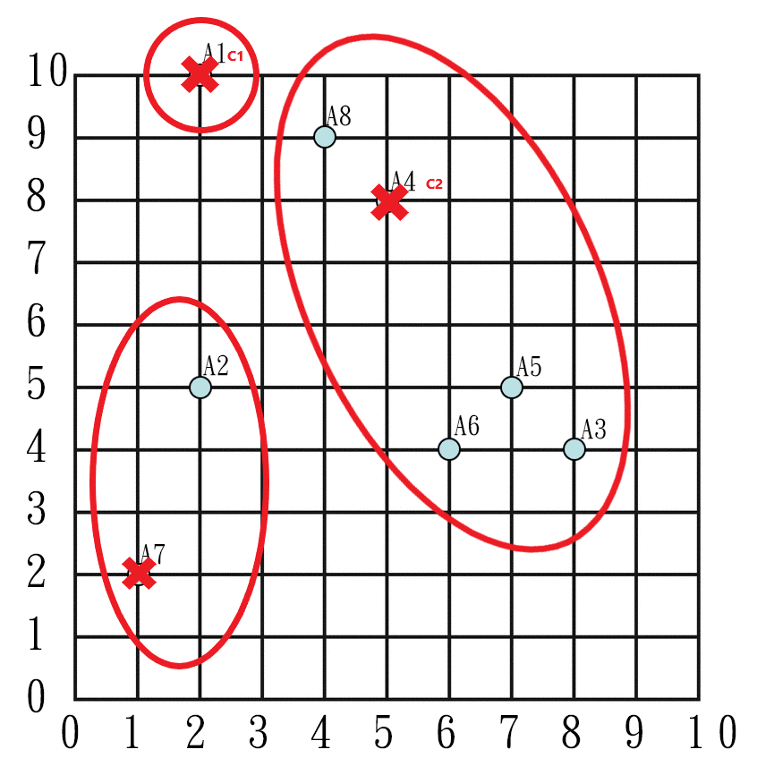

|  |  |  |
| --- | --- | --- |
|  | x | y |
| C1 | 2 | 10 |
| C2 | 6 | 6 |
| C3 | 1.5 | 3.5 |

|  |  |  |  |  |  |  |  |  |
| --- | --- | --- | --- | --- | --- | --- | --- | --- |
| Iteration 2 | | | | | | | | |
| Centroid(C1, C2, C3) | | | | | | | | |
| Instance | A1 | A2 | A3 | A4 | A5 | A6 | A7 | A8 |
| C1 dist. | 0.0000 | 5.0000 | 8.4853 | 3.6056 | 7.0711 | 7.2111 | 8.0623 | 2.2361 |
| C2 dist. | 5.6569 | 4.1231 | 2.8284 | 2.2361 | 1.4142 | 2.0000 | 6.4031 | 3.6056 |
| C3 dist. | 6.5192 | 1.5811 | 6.5192 | 5.7009 | 5.7009 | 4.5277 | 1.5811 | 6.0415 |
| Cluster Assigned | C1 | C3 | C2 | C2 | C2 | C2 | C3 | C1 |

|  |  |  |
| --- | --- | --- |
|  | x | y |
| C1 | 3 | 9.5 |
| C2 | 6.5 | 5.25 |
| C3 | 1.5 | 3.5 |

|  |  |  |  |  |  |  |  |  |
| --- | --- | --- | --- | --- | --- | --- | --- | --- |
| Iteration 3 | | | | | | | | |
| Centroid(C1, C2, C3) | | | | | | | | |
| Instance | A1 | A2 | A3 | A4 | A5 | A6 | A7 | A8 |
| C1 dist. | 1.1180 | 4.6098 | 7.4330 | 2.5000 | 6.0208 | 6.2650 | 7.7621 | 1.1180 |
| C2 dist. | 6.5431 | 4.5069 | 1.9526 | 3.1325 | 0.5590 | 1.3463 | 6.3885 | 4.5069 |
| C3 dist. | 6.5192 | 1.5811 | 6.5192 | 5.7009 | 5.7009 | 4.5277 | 1.5811 | 6.0415 |
| Cluster Assigned | C1 | C3 | C2 | C1 | C2 | C2 | C3 | C1 |

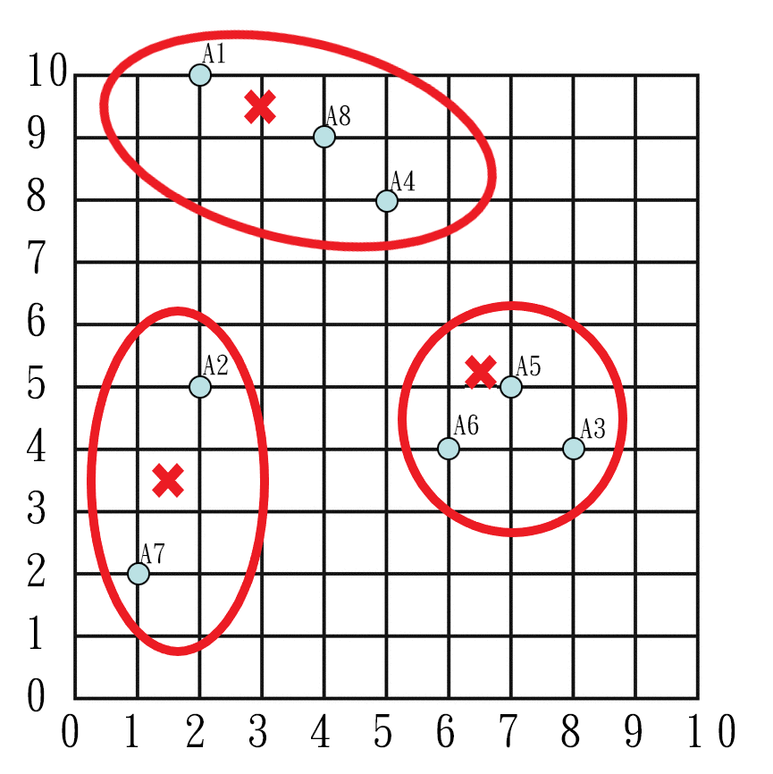

|  |  |  |
| --- | --- | --- |
|  | x | y |
| C1 | 3.6667 | 9 |
| C2 | 7 | 4.3333 |
| C3 | 1.5 | 3.5 |

|  |  |  |  |  |  |  |  |  |
| --- | --- | --- | --- | --- | --- | --- | --- | --- |
| Iteration 4 | | | | | | | | |
| Centroid(C1, C2, C3) | | | | | | | | |
| Instance | A1 | A2 | A3 | A4 | A5 | A6 | A7 | A8 |
| C1 dist. | 1.9437 | 4.3333 | 6.6165 | 1.6667 | 5.2068 | 5.5176 | 7.4907 | 0.3333 |
| C2 dist. | 7.5572 | 5.0442 | 1.0541 | 4.1767 | 0.6667 | 1.0541 | 6.4377 | 5.5478 |
| C3 dist. | 6.5192 | 1.5811 | 6.5192 | 5.7009 | 5.7009 | 4.5277 | 1.5811 | 6.0415 |
| Cluster Assigned | C1 | C3 | C2 | C1 | C2 | C2 | C3 | C1 |

No change = convergence.

1. Link

|  |  |  |  |  |  |  |
| --- | --- | --- | --- | --- | --- | --- |
| User-based | | | | | | |
|  | r_i · r_k | ||r_i|| ||r_k|| | sim(u_k, u_i) |  | prediction Kiss | prediction GnR |
| f(Fred, John) | 18 | 21.12463017 | 0.852085923 |  | 2.3301714 | 1.552984631 |
| f(Lillian, John) | 20 | 20.10596926 | 0.994729463 |  |  |  |
| f(Cathy, John) | 20 | 21 | 0.952380952 |  |  |  |

For Kiss, there is a predicted rating of 2.33 > 2.0 therefore it is recommended.

For GnR, the predicted rating is 1.55 < 2.0 therefore it is not recommended.

|  |  |  |  |  |  |
| --- | --- | --- | --- | --- | --- |
| Item-based | | | | | |
|  | r_i · r_k | ||r_i|| ||r_k|| | sim(u_k, u_i) |  | prediction Kiss |
| f(Bon Jovi, Kiss) | 13 | 13.09580085 | 0.992684613 |  | 2.4286809 |
| f(Metallica, Kiss) | 10.5 | 13.66793693 | 0.76822128 |  |  |
| f(Scorpions, Kiss) | 10.5 | 11.20546742 | 0.937042571 |  |  |
| f(AC/DC, Kiss) | 13.5 | 16.41645516 | 0.82234562 |  |  |

For Kiss, the predicted rating is 2.43 > 2.0 therefore it is recommended.

|  |  |  |  |  |  |
| --- | --- | --- | --- | --- | --- |
| Item-based | | | | | |
|  | r_i · r_k | ||r_i|| ||r_k|| | sim(u_k, u_i) |  | prediction GnR |
| f(Bon Jovi, GnR) | 10 | 14 | 0.714285714 |  | 1.586354 |
| f(Metallica, GnR) | 14.5 | 14.6116392 | 0.992359571 |  |  |
| f(Scorpions, GnR) | 10.5 | 11.97914855 | 0.876523065 |  |  |
| f(AC/DC, GnR) | 17 | 17.54992877 | 0.9686649 |  |  |

For GnR, the predicted rating is 1.59 < 2.0 therefore it is not recommended.

1. 4

|  |  |  |  |
| --- | --- | --- | --- |
| 1-Itemsets | | | |
| Rank | Itemset | Support Count | Support |
| 1 | d | 9 | 0.9 |
| 2 | b | 7 | 0.7 |
| 3 | e | 6 | 0.6 |
| 4 | a | 5 | 0.5 |
| 5 | c | 5 | 0.5 |

|  |  |  |  |
| --- | --- | --- | --- |
| 2-Itemsets | | | |
| Rank | Itemset | Support Count | Support |
| 1 | {b, d} | 6 | 0.6 |
| 2 | {d, e} | 6 | 0.6 |
| 3 | {a, d} | 4 | 0.4 |
| 4 | {a, e} | 4 | 0.4 |
| 5 | {b, e} | 4 | 0.4 |
| 6 | {c, d} | 4 | 0.4 |
| 7 | {a, b} | 3 | 0.3 |
| 8 | {b, c} | 3 | 0.3 |
| 9 | {a, c} | 2 | 0.2 |
| 10 | {c, e} | 2 | 0.2 |

|  |  |  |  |
| --- | --- | --- | --- |
| 3-Itemsets | | | |
| Rank | Itemset | Support Count | Support |
| 1 | {a, d, e} | 4 | 0.4 |
| 2 | {b, d, e} | 4 | 0.4 |
| 3 | {a, b, d} | 2 | 0.2 |
| 4 | {a, b, e} | 2 | 0.2 |
| 5 | {b, c, d} | 2 | 0.2 |
| 6 | {a, b, c} | 1 | 0.1 |

|  |  |  |
| --- | --- | --- |
| 3-Itemsets | | |
| Itemset | Support Count | Support |
| ABD | 2 | 0.2 |
| ABE | 2 | 0.2 |
| BCD | 2 | 0.2 |
| BCE | 1 | 0.1 |
| BDE | 4 | 0.4 |

|  |  |  |
| --- | --- | --- |
| 3-Itemsets | | |
| Itemset | Support Count | Support |
| BDE | 4 | 0.4 |

All except BDE get pruned.

* 1. 